Translation function in Abritas v13

Microsoft Edge browser
Open the www.homechoicebristol.co.uk website using Edge browser. On any page you can right click and this will give you the option to choose translate

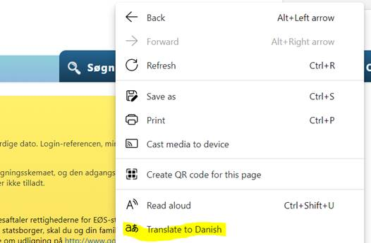

It places a widget at the right hand side of the URL

Click on it and you can choose which language you want to use

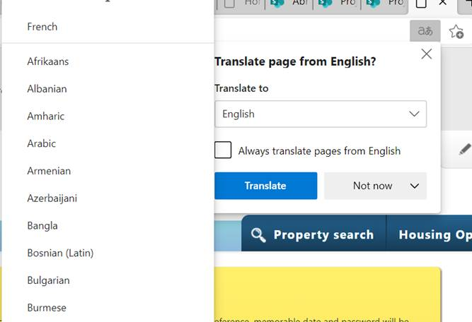

Google Chrome browser
Open the www.homechoicebristol.co.uk website using Chrome browser. On any page you can right click and this will give you the option to choose translate

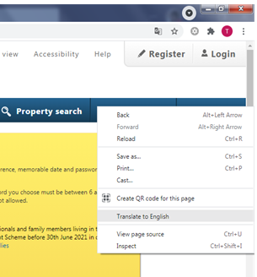

It places a widget at the right hand side of the URL

Click on the widget and the following will appear, click on the 3 dots on the right side

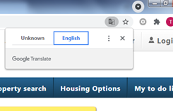

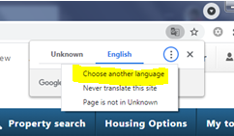

Click on Choose another language and select the language from the dropdown list – as shown
